**STUDENT MANAGEMENT SYSTEM**

MINI PROJECT CS1010 LAB

*A report submitted for Mini Project for the course CS1010 Lab*

*by*

**NAME:** Koushik Sripathi Panditaradhyula

**Register No:** 123CS0021



Department of Computer Science and Engineering

National Institute of Technology Rourkela

Odisha, 769008

Contents

1. Introduction
2. Code
3. Output Screenshots

**Introduction:**

Let us consider the given scenario. The institute wants to store the details of the students as roll number, first name, last name, and CGPA. Therefore, to store all these details a student database system was created. This system is not only able to store the data that is entered but also modify and check the data using certain functions. The functions that can done are given below:

1. Add student details: The entries of each student including all the student details are entered.
2. Finding the student by their name: The details of a particular student can be found by entering their name.
3. Finding the student by their roll number: The details of a particular student can be found by entering their unique registered number or roll number in short.
4. Total count: The total number of students or the count of the number of students will be shown.
5. Checking the students who have passed: by entering the cutoff CGPA, the system can filter out those students who have crossed that cutoff CGPA.
6. Updating the entries: The details of the student can be modified and corrected if any mishap has occurred in entering the details.
7. Deleting the entries: The details of students who are not in the institute can be deleted.

**Code:**

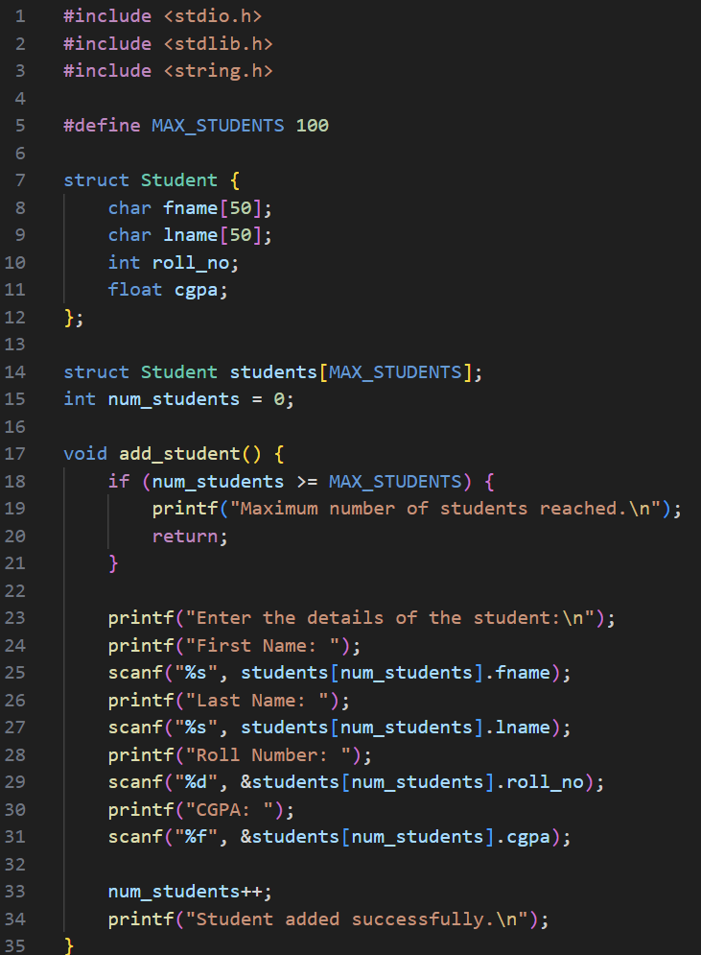

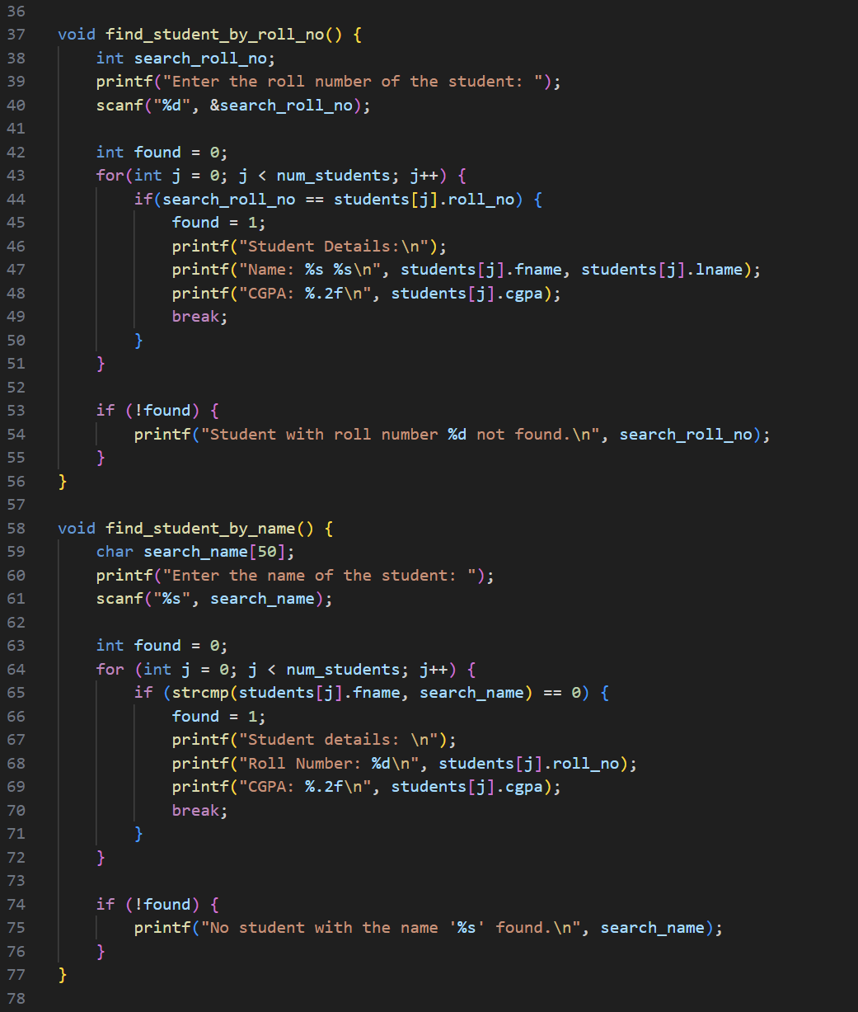

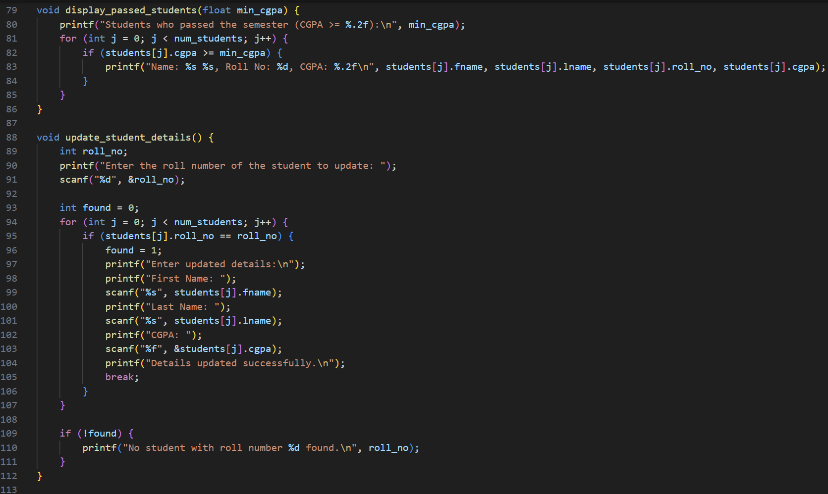

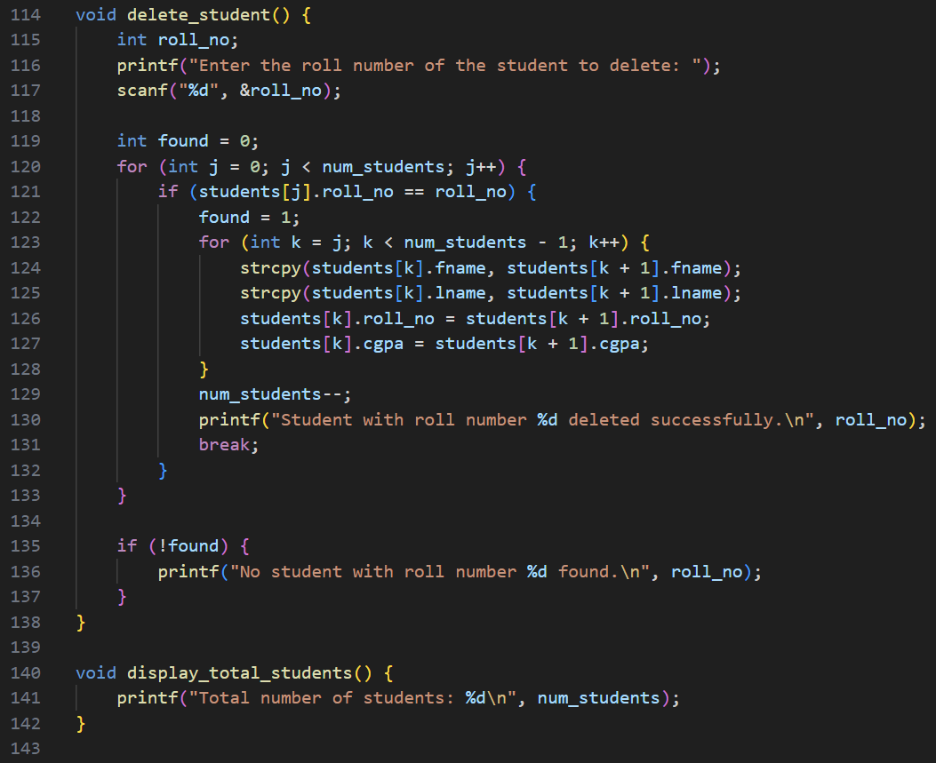

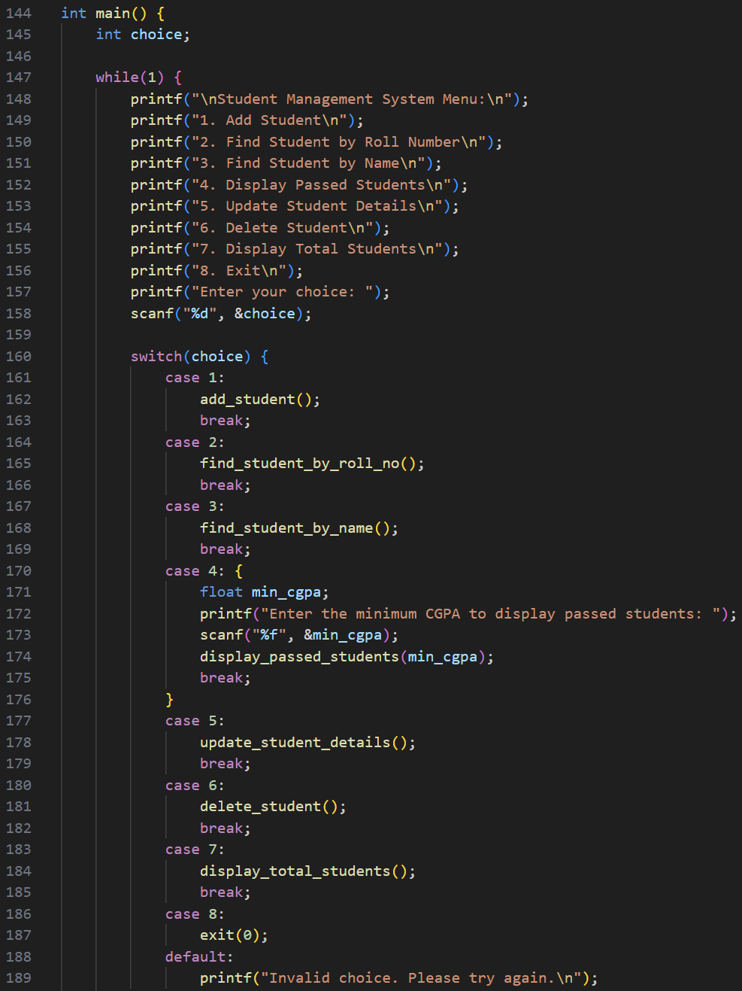

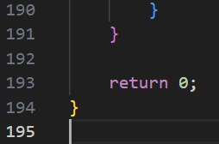

Outputs:

